**Group 1**

AdamWilliam Engsig, Anders Fischer-Nielsen, AndersWind Steffensen, Cecilie Strunge Jensen, Mikael Lindemann Jepsen, Morten Albertsen

You use the exclusion relation in the first part of the model (ReceiveAttendanceRecord and PatientCheckIn). However, in this case is possible that patient do checkin many times. Why did not you use self exclusion in this case?

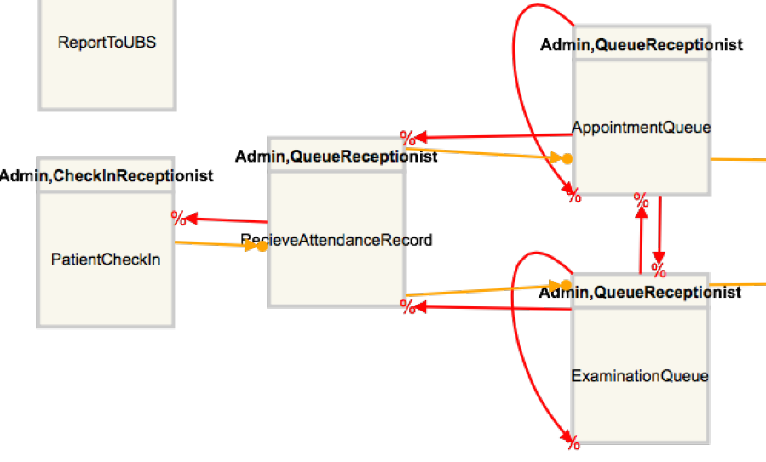

There should be response relations to make sure that events are actually required. With no response relations, it is possible to finish the execution in the middle of the process (because ther is no pending events).

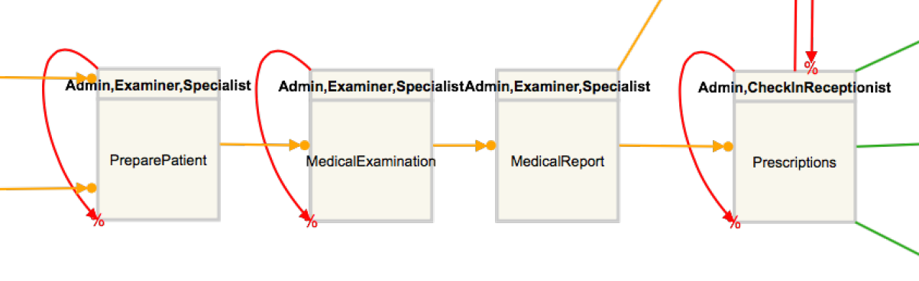

After an appointment a specialist provides a Medical Report. After an examination, it is provided a Medical examination report. Thus, these events should me modeled separately. 

The medical examination is executed and the specialist creates a medical report. The specialist may (i) request some exams, (ii) recommend an appointment with another specialist, (iii) or both, (iv) or may recommend some medications and ask the patient to return, (v) or may recommend some surgery. These options are not included in the process model. In addition, these options are not possible after exams. This is another reason to model appointments and exams separately.

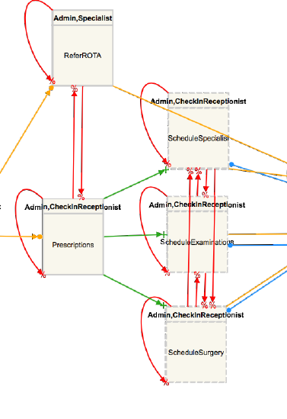

According to the description of the healthcare process: “It is possible that a specialist recommend for a specific patient a maximal priority over other patients concerning exams, appointments (with other specialist) or surgery. In this case, the patient is referred to other sector called ROTA. In this sector an auditor (a specialist working for Brazilian Government) will confirm the urgency of each case.

In this case an auditor has to approve the recommendation otherwise there will be no charging of the Brazilian government.

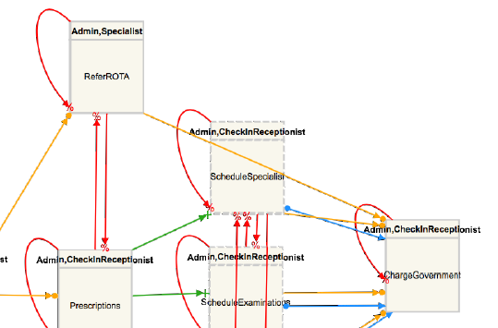

According to the healthcare description, the patient may return to the hospital as many time as it is necessary. However, in your model the patient can go through the receptions 1 and 2 only once.

It is supposed that a treatment may require more than one visit to the hospital. In your model there is no possibility to a patient returns to the hospital to continue a treatment. In this case, do you think that when a patient returns to the hospital a new instance will be created in the information system? How will your information system will manage long-terms treatments?

Questions:

- In fact in the provided healthcare process description there is no information about who is responsible to prepare the patient. We may assume that a nurse is responsible for preparing the patients.

- According to the provided healthcare process description “The physician may recommend the patient an appointment with a specialist or request some exams.

In this case, they are exclusive. A specialist only can recommend exams related to its speciality.

- Every service will be charged the Brazilian government. In the case of ROTA, the costs are very high and for this reason it is necessary a previous approval of an auditor.

- Only specialists can recommend patients to ROTA.